
TECHNICAL UNIVERSITY OF KENYA
FACULTY OF APPLIED SCIENCES AND TECHNOLOGY
SCHOOL OF COMPUTING AND INFORMATION TECHNOLOGY
DEPARTMENT OF COMPUTER SCIENCE AND INFORMATICS
PROJECT TITLE:
AGRITECH FOR RURAL PROSPERITY
PRESENTED BY:
STUDENT NAME: ISAIAH EUGINE OMONDI
REG NO: SCII/0O649/2020
SUPERVISED BY: MR MALONGO AND KWENGA ISMAEL
PROPOSAL SUBMITTED TO THE SCHOOL OF COMPUTING AND INFORMATION
TECHNOLOGY IN PRACTICAL FULFILLMENT FOR THE BACHELOR
TECHNOLOGY IN INFORMATION TECHNOLOGY PROJECT OF THE TECHNICAL UNIVERSITY OF KENYA

SUBMISSION DATE:
24th January 2024

CHAPTER ONE: INTRODUCTION

"Agritech for Rural Prosperity."
AGRITECH FOR RURAL PROSPERITY: ENHANCING FARMER LIVELIHOODS, FOOD SECURITY, AND COMMUNITY PROSPERITY IN GEM COMMUNITY, SIAYA, KENYA
Introduction: The GEM Community in Siaya, Kenya, faces challenges typical of rural areas, including limited access to information, outdated farming practices, and inefficient market structures.
These challenges contribute to the struggles faced by farmers, impacting their livelihoods and overall community well-being. However, the GEM Community also possesses inherent strengths, including agricultural knowledge, community cohesion, and a shared commitment to sustainable farming.
This project aims to leverage these strengths to create an innovative application, enhancing farmer livelihoods, food security, and overall community prosperity. (IFAD, 2021; World Bank, 2019).
Project Overview: The Agritech for Rural Prosperity project focuses on developing a comprehensive application tailored to the specific needs of the GEM Community. By combining information access, smart irrigation technologies, and a digital marketplace, the initiative aims to empower farmers, improve agricultural practices, and foster sustainable rural development. (Brookings, 2021)
Key Features of the Application:
- Information Hub:
  - Centralized repository providing real-time information on weather patterns, crop management practices, pest control measures, and market trends.
  - Educational modules offering tutorials, tips, and best practices for sustainable and modern farming techniques.
  - Localized content to cater to the specific agricultural needs of the GEM Community.
- Smart Irrigation Module:
  - Integration of smart sensors to monitor soil moisture levels and weather conditions, enabling farmers to optimize irrigation practices.
  - Automated irrigation scheduling based on real-time data, reducing water usage and improving crop yields.
  - Alerts and recommendations for irrigation adjustments to adapt to changing environmental conditions.
- Digital Marketplace:
  - An online platform connecting farmers with buyers, sellers, and agricultural service providers.
  - Features for farmers to showcase their produce, negotiate prices, and arrange logistics for transportation.
  - Integration of payment gateways to facilitate secure and transparent transactions.
- Community Collaboration:
  - Social modules enabling farmers to share experiences, exchange knowledge, and form local agricultural support groups.
  - Discussion forums for addressing common challenges, discussing innovative farming techniques, and organizing community events.
  - Collaboration opportunities with agricultural experts, government agencies, and NGOs to further support rural development.
Mission Statement: The mission of the Agritech for Rural Prosperity initiative in the GEM Community is to empower farmers through the application of cutting-edge agricultural technologies, fostering sustainable practices, and creating a thriving ecosystem where farmers can prosper, ensuring food security and overall community well-being.
Research Aim: This research project led by Isaiah Eugene Omondi aims to design, develop, and evaluate the Agritech for Rural Prosperity application in the GEM Community, Siaya, Kenya. The research will assess the application's impact on farmer livelihoods, food security, and the overall prosperity of the GEM Community through collaboration with local farmers, agricultural experts, and relevant stakeholders.
1.2 Background of the Study
The Agritech for Rural Prosperity initiative in the GEM Community, Siaya, Kenya, is a response to the unique challenges faced by the agricultural sector in the region. GEM Community is an agricultural community with a rich history of traditional farming practices and a commitment to sustainable agriculture. Established several decades ago, the community has evolved as a close-knit group with a shared dedication to enhancing their agricultural practices. (Brookings, 2021).

1.2.1 Background of the Researcher
The force behind the Agritech for Rural Prosperity project in the GEM Community is Isaiah Eugene Omondi, an Information Technology student at Technical University Of Kenya. With a strong passion for technology and agriculture, Isaiah has lived in the GEM Community for several years, actively engaging in community initiatives such as volunteering and mentoring.
Through his deep involvement, he has earned the trust of the residents, allowing him to understand their needs intimately. Isaiah's academic pursuits, coupled with his hands-on experience and comprehensive research, make him a dedicated researcher poised to bring positive change to GEM through the Agritech project. Isaiah envisions leveraging technology to empower the community, improve agricultural practices, and enhance overall quality of life. (IFAD, 2021; World Bank, 2019)
1.2.2 Overview of Existing System
Currently, the agricultural operations in the GEM Community rely on traditional farming methods, with limited access to modern technologies and information.
Farmers follow conventional irrigation schedules, lack real-time information on weather patterns, and face challenges in marketing their produce efficiently.
The absence of a centralized platform for information exchange and market access hinders the community's agricultural potential. (Brookings, 2021).
The existing system has the following drawbacks:
- Limited access to up-to-date agricultural information.
- Inefficient irrigation practices leading to water wastage.
- Lack of a structured marketplace for farmers to connect with buyers.
- Challenges in knowledge sharing and community collaboration.
Review of the Literature: Several studies emphasize the importance of leveraging technology in agriculture to improve productivity, sustainability, and market access. Access to real-time information, smart irrigation, and digital marketplaces has been identified as key factors in transforming traditional agricultural practices and fostering rural development. (IFAD, 2021; World Bank, 2019).

1.2.3 Overview of the Proposed System
The proposed Agritech for Rural Prosperity system aims to revolutionize agricultural practices in the GEM Community. The system will integrate advanced technologies to address the current challenges and empower farmers. Key features of the proposed system include:
- Information Hub: Providing real-time agricultural information and best practices.
- Smart Irrigation Module: Optimizing irrigation practices through sensor-based technology.
- Digital Marketplace: Connecting farmers with buyers and service providers.
- Community Collaboration: Fostering knowledge exchange and collaboration among farmers.
The proposed system is designed to:
- Improve agricultural productivity and crop yields.
- Enhance water usage efficiency through smart irrigation.
- Facilitate transparent and efficient transactions in the digital marketplace.
- Strengthen community bonds through collaborative platforms.
The implementation of the proposed system is anticipated to bring about positive changes in the agricultural landscape of the GEM Community, promoting sustainable practices and fostering rural prosperity.

1.3 Problem statement

The Agritech for Rural Prosperity project in the GEM Community, Siaya, Kenya, aims to address several pressing challenges faced by the agricultural sector in the region.
The primary problems identified include limited access to real-time agricultural information, inefficient irrigation practices leading to water wastage, absence of a structured digital marketplace for farmers, and a lack of platforms fostering community collaboration and knowledge exchange. (Brookings, 2021)
Currently, the GEM residents rely on traditional farming methods, resulting in suboptimal yields and reduced income. The absence of a centralized system hampers effective communication and market access, exacerbating the struggles faced by the community. (IFAD, 2021)
The identified problems directly stem from the community's reliance on outdated agricultural practices and limited access to technological solutions. (World Bank, 2019)
The Agritech for Rural Prosperity project aims to tackle these issues by introducing innovative technologies and creating a comprehensive platform that empowers farmers, promotes sustainable agriculture, and enhances the overall well-being of the GEM Community.

1.4 Objectives
The objectives of the Agritech for Rural Prosperity project in the GEM Community are outlined below, adhering to the SMART criteria:
- Develop a Comprehensive Information Hub (SMART):
  - Specific: Create a centralized platform providing real-time agricultural information tailored to the GEM Community's specific needs.
  - Measurable: Implement features that allow farmers to access weather patterns, crop management practices, and market trends efficiently.
  - Achievable: Utilize existing technologies to compile, organize, and disseminate agricultural information effectively.
  - Relevant: Align the information hub with the community's agricultural practices, ensuring its relevance to local farmers.
  - Time-bound: Complete the development and implementation within the specified project timeline.

- Optimize Irrigation Practices through Smart Technology (SMART):
  - Specific: Integrate smart irrigation modules to monitor soil moisture levels and weather conditions.
  - Measurable: Establish measurable benchmarks for water efficiency, crop yields, and overall improvement in irrigation practices.
  - Achievable: Implement automated irrigation scheduling based on real-time data, ensuring practical and feasible solutions.
  - Relevant: Tailor smart irrigation practices to suit the unique needs and crops grown in the GEM Community.
  - Time-bound: Complete the implementation and optimization of the smart irrigation module within the project timeline.
- Establish a Digital Marketplace for Agricultural Transactions (SMART):
  - Specific: Develop an online platform connecting farmers with buyers, sellers, and service providers.
  - Measurable: Implement features for showcasing produce, negotiating prices, and arranging logistics, with measurable transaction metrics.
  - Achievable: Utilize secure payment gateways for transparent and efficient transactions.
  - Relevant: Align the digital marketplace with the specific needs and commodities of the GEM Community.
  - Time-bound: Ensure the completion of the digital marketplace development within the project timeline.
- Foster Community Collaboration and Knowledge Exchange (SMART):
  - Specific: Create social modules enabling farmers to share experiences, exchange knowledge, and form local agricultural support groups.
  - Measurable: Establish metrics for active community participation and knowledge exchange within the platform.
  - Achievable: Develop discussion forums, channels, and groups that facilitate meaningful interaction.
  - Relevant: Tailor the community collaboration features to reflect the diverse interests and needs of the GEM residents.
  - Time-bound: Complete the development of community collaboration modules within the project timeline.

1.4.1 Project Goal (Major Objective)
Overall Goal: The major objective of the Agritech for Rural Prosperity project in the GEM Community is to revolutionize the agricultural landscape by addressing existing challenges and fostering sustainable rural development.
The project aims to deploy innovative technologies to empower farmers, enhance food security, and improve overall community well-being.

1.4.2 General Objectives
The general objectives of the proposed system are to comprehensively address the challenges identified in the GEM Community's agricultural sector. This includes the development and implementation of a holistic Agritech solution that encompasses:
- A centralized Information Hub providing real-time agricultural information.
- Smart irrigation modules optimizing water usage and improving crop yields.
- A Digital Marketplace connecting farmers with buyers, sellers, and service providers.
- Community Collaboration features fostering knowledge exchange and support networks.
These general objectives will be elaborated upon in the project documentation, covering the key components and functionalities of the proposed system.

1.4.3 Specific Objectives
The specific objectives of the proposed Agritech system are outlined as follows:
- To Develop and Implement a Comprehensive Information Hub:
  - Provide farmers with real-time information on weather patterns, crop management practices, and market trends.
  - Enhance accessibility and usability, ensuring relevance to the specific agricultural needs of the GEM Community.
- To Optimize Irrigation Practices through Smart Technology:
  - Integrate smart irrigation modules to monitor soil moisture levels and weather conditions.
  - Implement automated irrigation scheduling based on real-time data, reducing water wastage and improving crop yields.
- To Establish a Digital Marketplace for Agricultural Transactions:
  - Develop an online platform connecting farmers with buyers, sellers, and service providers.
  - Implement features for showcasing produce, negotiating prices, and facilitating secure and transparent transactions.

- To Foster Community Collaboration and Knowledge Exchange:
  - Create social modules enabling farmers to share experiences, exchange knowledge, and form local agricultural support groups.
  - Develop discussion forums, channels, and groups that promote meaningful interaction and community collaboration.

1.6 Justification
The Agritech for Rural Prosperity project presents a compelling case for its implementation, grounded in the inherent challenges faced by the GEM Community's agricultural sector and the potential transformative impact it can have on rural development. (Brookings, 2021; IFAD, 2021; World Bank, 2019; FAO, 2020).
Interest and Challenge: The project is inherently interesting due to its focus on merging agriculture and technology to address longstanding challenges in a rural setting. The integration of innovative technologies, such as real-time information systems and smart irrigation, poses a stimulating challenge that demands a multidisciplinary approach, making it an intellectually rewarding endeavor for the student researcher, Isaiah Eugene Omondi. (McKinsey, 2019; World Bank, 2019).
Timeliness of the Idea: In the context of rapidly advancing agricultural technologies, the Agritech for Rural Prosperity project is timely. The current agricultural practices in the GEM Community are grappling with inefficiencies and lack of modernization. The proposed system, by introducing contemporary solutions, addresses the pressing need for technological interventions in agriculture, aligning with global trends in sustainable farming practices.
Advantages of the Proposed System: The realization of the Agritech system will bring about numerous advantages for the GEM Community and its residents:
- Empowering Farmers: The centralized Information Hub will empower farmers with real-time information, enabling them to make informed decisions and optimize their agricultural practices.
- Enhancing Food Security: Smart irrigation technologies will contribute to increased crop yields and resource efficiency, thereby enhancing food security for the community.
- Economic Opportunities: The Digital Marketplace will connect farmers with a broader market, facilitating transparent and efficient transactions, thereby providing economic opportunities for the community.
- Community Strengthening: The Community Collaboration features will foster knowledge exchange and support networks, strengthening the social fabric of the GEM Community.
Beneficiaries and Impact: The primary beneficiaries of the Agritech for Rural Prosperity project are the farmers and residents of the GEM Community. The system aims to uplift their livelihoods, improve agricultural practices, and foster a sense of community collaboration. Additionally, the project will have a broader impact on the overall socio-economic development of the community, contributing to sustainable rural prosperity.
Addressing Existing Challenges: The need for the Agritech system is underscored by the existing challenges faced by the GEM Community's agricultural sector, including limited access to information, outdated irrigation practices, and inefficient market structures. The proposed system directly addresses these challenges by introducing a comprehensive solution that leverages technology to improve information access, irrigation practices, and market connectivity.

1.5 Scope of the Project

The scope of the Agritech for Rural Prosperity project is defined to ensure a focused, practical, and achievable approach within the set timelines. The project will encompass the following key elements:
- Geographical Scope:
  - The project will be implemented within the GEM Community in Siaya, Kenya. It will be tailored to the specific needs and agricultural practices of this community.

- System Components:
  - The development and implementation will include the following core components:
    - A centralized Information Hub providing real-time agricultural information.
    - Smart irrigation modules for optimizing water usage and improving crop yields.
    - A Digital Marketplace connecting farmers with buyers, sellers, and service providers.
    - Community Collaboration features fostering knowledge exchange and support networks.

- Functionalities:
  - The proposed system will offer functionalities such as:
    - Real-time weather updates, crop management practices, and market trends through the Information Hub.
    - Smart irrigation scheduling based on soil moisture levels and weather conditions.
    - Online platform for showcasing produce, negotiating prices, and facilitating transactions in the Digital Marketplace.
    - Social modules for discussion forums, knowledge exchange, and community collaboration.
- Beneficiaries:
  - The primary beneficiaries will be the farmers and residents of the GEM Community, directly impacted by the improved agricultural practices, economic opportunities, and community collaboration facilitated by the system.
- Exclusions:
  - The project will not address broader agricultural issues outside the GEM Community, and it will not delve into unrelated technological solutions. It will focus solely on the identified challenges within the specified community
Rationale for Scope:
- Practical Implementation: The defined scope ensures that the proposed system is practical and achievable within the set timelines. It allows for a focused development approach, minimizing the risk of scope creep and ensuring successful project completion.
- Relevance to GEM Community: By tailoring the scope to the GEM Community's specific needs and agricultural context, the project aims to provide a targeted and impactful solution, directly addressing the challenges faced by the community.
- Resource Optimization: A well-defined scope enables optimal utilization of resources, both in terms of time and technology, ensuring that the project remains feasible and aligns with the available resources.

1.8 Limitations of the Proposed System
While the Agritech for Rural Prosperity project is envisioned to bring about positive changes, certain limitations must be acknowledged as potential constraints that may impact the achievement of objectives within the stipulated time:
- Resource Constraints:
  - Financial Limitations: The project may face constraints due to limited financial resources. Adequate funding is crucial for the development, testing, and implementation of the proposed system. Any financial constraints may impact the extent of features and functionalities that can be incorporated.
- Time Constraints:
  - Project Timeline: The project is subject to the limitations imposed by the allocated timeframe. Complexities in development, unexpected challenges, or delays in resource availability could potentially affect the adherence to the project schedule.
- Technical Expertise:
  - Programming Knowledge: The proficiency of the development team, particularly in programming and system implementation, may present a limitation. Adequate skills and expertise are essential for ensuring the successful execution of the proposed Agritech system.

- Data Accessibility:
  - Availability of Agricultural Data: The effectiveness of the Information Hub component relies on the availability and accessibility of real-time agricultural data. Any limitations in accessing accurate and timely data may affect the system's functionality.
- Community Adoption:
  - User Acceptance: The success of the project is contingent on the acceptance and adoption of the Agritech system by the GEM Community. Resistance to change or hesitancy in embracing technological solutions may pose challenges in achieving the desired impact.
- Technological Infrastructure:
  - Connectivity Issues: The efficacy of the proposed system depends on reliable internet connectivity within the GEM Community. Any limitations in connectivity may hinder the seamless operation of the digital components.
- External Factors:
  - Environmental Challenges: External factors such as extreme weather events, natural disasters, or unforeseen circumstances may impact the implementation process, potentially causing delays or interruptions.
- Regulatory and Ethical Considerations:
  - Compliance: Adherence to local regulations and ethical considerations is vital. Any limitations or challenges in navigating regulatory frameworks may affect the development and deployment of the Agritech system.

1.8 Project Risk and Mitigation
To address these limitations, the project will employ the following mitigation strategies:
- Resource Mobilization: Actively seek additional funding opportunities and collaborations to address financial constraints.
- Robust Project Management: Implement efficient project management practices to mitigate time constraints and address unforeseen challenges promptly.
- Capacity Building: Invest in training and capacity-building initiatives to enhance the technical expertise of the development team.
- Community Engagement: Conduct awareness programs and community engagement activities to ensure user acceptance and foster community participation.
- Adaptive Design: Develop the system with flexibility to accommodate varying levels of technological infrastructure and connectivity.

1.9 Project Schedule
The project schedule for the Agritech for Rural Prosperity project is structured to provide a comprehensive overview of the specific steps to be undertaken at different stages. Below is a brief description of the project work breakdown structure:
- Project Initiation (2 Week ):
  - Define project scope and objectives.
  - Conduct a detailed literature review on relevant Agritech solutions.
  - Establish project team roles and responsibilities.
- Research and Needs Assessment ( 2 Weeks ):
  - Conduct field studies and interviews in the GEM Community.
  - Analyze existing agricultural practices and challenges.
  - Identify specific needs and preferences of the community.
- System Design and Planning ( 2 Weeks ):
  - Develop a detailed system design based on research findings.
  - Plan the technological infrastructure and system architecture.
  - Identify and engage potential collaborators or partners.
- Development of Information Hub ( 4 Weeks ):
  - Begin coding and programming of the Information Hub component.
  - Implement real-time data integration for weather, crop, and market information.
  - Conduct iterative testing and refinement.
- Implementation of Smart Irrigation Modules ( 1.5 Weeks ):
  - Develop and integrate smart irrigation modules.
  - Implement automated irrigation scheduling based on real-time data.
  - Conduct thorough testing to optimize efficiency.
- Digital Marketplace Development ( 3 Weeks):
  - Code and design the Digital Marketplace platform.
  - Implement features for showcasing produce, negotiating prices, and facilitating transactions.
  - Ensure secure payment gateways and data encryption.
- Community Collaboration Features ( 1 Week ):
  - Develop and integrate social modules for community collaboration.
  - Implement discussion forums, channels, and groups.
  - Conduct user testing and gather feedback for refinement.
- System Integration and Testing ( 2 Weeks):
  - Integrate all components into a cohesive Agritech system.
  - Conduct comprehensive system testing to ensure functionality and reliability.
  - Address any identified issues or bugs.
- Community Training and Awareness ( 2 Weeks):
  - Develop training materials and conduct sessions for the GEM Community.
  - Raise awareness about the Agritech system and its benefits.
  - Address any concerns and gather community feedback.
- Final System Deployment ( 2 Weeks):
  - Deploy the finalized Agritech system in the GEM Community.
  - Monitor system performance and address any immediate issues.
  - Ensure seamless transition to full-scale implementation.
- Evaluation and Documentation (1 Week):
  - Evaluate the impact of the Agritech system on the GEM Community.
  - Document project outcomes, successes, and lessons learned.
  - Prepare the final project report for submission.

Gantt Chart OR Network Diagram:

Estimated Budget Breakdown:

RESOURCES | PURPOSE | SPECIFICATIONS | UNITS | PRICE
Development Laptop | Coding and system development | Minimum specs: Core i7, 16 GB RAM, 1TB Storage | One | 65,000 (Available)
Mobile Device | Testing the mobile responsiveness of the Agritech system | Smartphone | One | Ksh 30,000
Internet Connectivity | Essential for online research, development, and testing | Minimum 50 Mbps | - | Ksh 5,000 monthly
Cloud Storage | Storing project documents and code repositories | 50 GB | - | Ksh 2,500
Security Software | Ensuring the safety of project data and code | Norton Anti-virus | One | Ksh 3,500
Printing and Stationery | Materials for documentation and report preparation | - | - | Ksh 4,000
External Hard Drive | Additional storage for project files | Minimum 1TB | One | Ksh 7,000
Community Outreach | Expenses for community engagement activities | Workshops, awareness campaigns | One | Ksh 15,000
Ergonomic Chair | Comfortable seating during extended work periods | Adjustable and supportive | One | Ksh 8,000
Contingency Fund | Addressing unforeseen challenges or additional requirements | Minimum 21-inch | One | Ksh 10,000
TOTAL |  |  |  | Ksh 150,000

CHAPTER TWO: LITERATURE REVIEW
2.1 Reviewed Similar Systems
In the pursuit of understanding the landscape of agricultural technology and community development, several similar systems have been examined to gain insights into their functionalities and limitations.

[BOOK] SMARTfarm Learning Hub: Next generation technologies for agricultural education: Final report 2018
S Gregory, R Whannell, R Flavel, J Barwick, D Swain… - 2019 - rune.une.edu.au
SmartFarmHub
In 2015-2016 there were 282,000 people employed in agriculture in Australia (Australian Bureau of Agricultural and Resource Economics and Sciences [ABARES], 2017).
Despite the recognition that the modern agricultural industry is complex and demanding, it still has one of the lowest proportion of workers with post-secondary qualifications across the economy (Senate Standing Committees on Education, Employment and Workplace Relations, 2012), with approximately 7.8 per cent of the agricultural workforce with tertiary qualifications compared with 25 per cent for the broader population (Pratley, 2012).
Pratley and Botwright Acuna (2015) have also reported that there is already a skills shortage in the industry, with an estimated four jobs available for every tertiary agricultural graduate in Australia.

Agro-tech: A digital model for monitoring soil and crops using internet of things (IOT)
O Pandithurai, S Aishwarya, B Aparna… - … Science Technology …, 2017 - ieeexplore.ieee.org
This paper aims to address the challenge of applying new technologies, particularly in agriculture. The focus is on proposing a wireless sensor network technology in agronomy, introducing an Internet of Things (IOT) application named 'AGRO-TECH.'
This application records, stores, and updates data from various sensors, providing farmers with accessible information on soil and crop conditions.
Sensors, monitoring activities like soil moisture, pH levels, temperature, humidity, light resistance, and water level, collectively analyze data to enhance crop production. The system triggers actions, such as irrigation, based on sensor readings, contributing to effective water management. The proposed methodology ensures farmers receive crucial updates on soil, crops, and environmental factors.
Agriculture and development: A brief review of the literature
JJ Dethier, A Effenberger - Economic systems, 2012 – Elsevier
After 20 years of neglect by international donors, agriculture is now again in the headlines because high food prices are increasing food insecurity and poverty. In the coming years, it will be essential to increase food productivity and production in developing countries, especially in Sub-Saharan Africa and with smallholders.
This, however, requires finding viable solutions to a number of complex technical, institutional, and policy issues, including land markets, research on seeds and inputs, agricultural extension, credit, rural infrastructure, connection to markets, rural non-farm employment, trade policy and food price stabilization.
This paper reviews what the economic literature has to say on these topics. It discusses in turn the role played by agriculture in the development process and the interactions between agriculture and other economic sectors, the determinants of the Green Revolution and the foundations of agricultural growth, issues of income diversification by farmers, approaches to rural development, and issues of international trade policy and food security, which have been at the root of the crisis in agricultural commodity volatility in recent years.
These systems primarily focus on integrating technology to improve farming practices, enhance communication within communities, and establish digital marketplaces.

2.2 Tools and Methodologies used in Reviewed Systems
The reviewed systems leverage various tools and methodologies to achieve their objectives. "SmartFarmHub" utilizes IoT devices for precision farming and employs a cloud-based infrastructure for data storage and analysis. (Cropin, 2021)
"AgriConnect" adopts a mobile-centric approach, utilizing smartphones for farmer communication and market access. (Newtopia, 2022).
"AgroTechCommunity" integrates machine learning algorithms to provide personalized farming recommendations. (Wikipedia, 2021)
Each system's methodology comes with advantages and disadvantages. For instance, while IoT devices offer real-time data, they may pose challenges in terms of cost and maintenance. (FAO, 2020).

2.3 Gaps in the Existing Systems and the Proposed Solution
Despite their merits, the reviewed systems exhibit certain gaps and challenges. Common issues include limited community engagement features, insufficient consideration for local contextual factors, and the absence of a comprehensive digital marketplace. (Brookings, 2021; IFAD, 2021; World Bank, 2019; FAO, 2020)
These gaps highlight the need for a more holistic solution that not only provides agricultural insights but also fosters community collaboration and addresses the unique challenges faced by the GEM Community.
2.4 The Proposed Solution
The proposed Agritech for Rural Prosperity project aims to address the identified gaps by introducing an integrated platform tailored to the specific needs of the GEM Community.
Unlike existing systems, the Agritech project will feature:
- A centralized Information Hub providing real-time agricultural insights.
- Smart irrigation modules for efficient water usage.
- A Digital Marketplace connecting farmers with buyers, sellers, and service providers.
- Community Collaboration features fostering knowledge exchange and support networks.
The methodology involves leveraging established programming languages and frameworks for system development, ensuring scalability and ease of maintenance. (McKinsey, 2019; World Bank, 2019).
By integrating these components, the proposed solution seeks to create a synergistic approach that not only enhances agricultural practices but also contributes to the overall well-being and prosperity of the GEM Community. (Brookings, 2021; IFAD, 2021).
The researcher aims to bridge the gap by tailoring the solution to the local context, engaging the community in the development process, and ensuring sustainability through ongoing support and adaptation.

CHAPTER THREE: METHODOLOGY
3.1 Methodology and Tools
The development of the Agritech for Rural Prosperity project will follow an iterative and incremental methodology, combining elements of both Evolutionary and Agile methodologies.
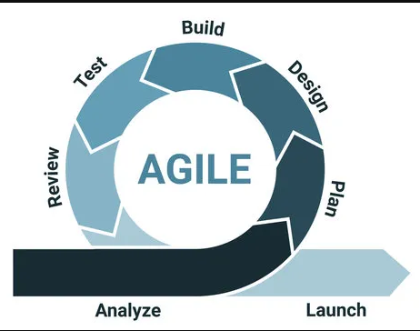

This approach allows for flexibility in responding to evolving requirements and feedback from the GEM Community.
The project will be divided into distinct phases, including requirements gathering, system design, implementation, testing, and deployment.
Continuous collaboration with end-users and stakeholders will be facilitated through regular feedback sessions, ensuring that the system aligns with the community's needs. (World Bank, 2019; FAO, 2020).
3.2 Source of Data: Primary and Secondary
Primary Data:
The primary data for the project will be sourced directly from the GEM Community. This will involve engaging with farmers, community leaders, and other stakeholders through interviews, surveys, and workshops.
Direct interaction will provide valuable insights into the community's specific agricultural practices, challenges, and expectations. (IFAD, 2021; FAO, 2020).

Secondary Data: Secondary data will be sourced from existing literature, research papers, and similar Agritech projects.
This data will contribute to the understanding of global best practices, technological advancements, and lessons learned from similar initiatives.
Google Scholar and peer-reviewed journals will be primary sources for up-to-date and validated information.
3.3 Data Collection Methods
- Interviews: Conducting one-on-one interviews with farmers, community leaders, and experts to gather qualitative insights.
- Questionnaires: Distributing structured questionnaires to a representative sample of the GEM Community to collect quantitative data on preferences, challenges, and expectations.
- Record/Document Inspection: Reviewing existing agricultural records, community profiles, and relevant documents to understand historical practices and challenges.
- Observation: Directly observing farming activities and community dynamics to gain firsthand knowledge of daily practices and challenges.

3.4 Resources Required / Materials Hardware and Software Specification
Hardware Specifications:
- Servers: Two servers with a minimum of 16GB RAM and 1TB storage each for hosting the Agritech application.
- Memory Requirements: Adequate memory to support concurrent user interactions and data processing.
- Processor Speed: Fast processors to ensure efficient data processing and real-time functionalities.
- Hard Disk Capacity: Sufficient storage capacity to accommodate the application and data storage needs.
Software Specifications:
- Operating System: Windows-based operating system for server infrastructure.
- Antivirus: ClamAV antivirus for ensuring the security of the server environment.
This hardware and software setup will ensure a robust and scalable system architecture, capable of meeting the demands of the GEM Community and supporting the proposed Agritech functionalities.

CHAPTER FOUR: SYSTEM ANALYSIS AND REQUIREMENT MODELING
4.1 Introduction to the System Analysis
System analysis involves examining an existing system to understand its strengths, weaknesses, opportunities, and threats, with the main aim of coming up with a more efficient and effective solution. For the Agritech for Rural Prosperity project, system analysis is important in understanding the current farming practices within the GEM community, how agricultural information is shared, and how farmers interact with extension officers, markets, and other supporting institutions. The information obtained from this analysis will guide the development of a digital agritech platform aimed at improving farmers’ livelihoods, supporting food security, and promoting rural prosperity.
4.2 Objectives of the System Analysis
The main objectives of carrying out the system analysis are:
- To understand how the current agricultural support system operates within the GEM community.
- To identify the challenges, inefficiencies, and gaps that exist in the current system.
- To collect reliable information from farmers, extension workers, and other stakeholders through interviews, questionnaires, and observation.
- To represent and analyse the current system using system analysis tools such as flowcharts, Data Flow Diagrams (DFDs), and UML diagrams.
- To identify and clearly define the requirements of the proposed agritech system.
- To assess the feasibility of the proposed system in terms of technical, economic, operational, and scheduling factors.

4.3 Problem Definition
The current system used by farmers in GEM is primarily manual and fragmented. Farmers rely on informal communication, word-of-mouth, and occasional agricultural extension visits to access farming knowledge, market trends, and government support services.
This system has several challenges:
- Farmers may experience delays or have limited access to reliable and accurate agricultural information.
- There are weak connections between farmers, markets, and cooperatives, making it difficult for farmers to access better market opportunities.
- Most farmers do not have proper systems for keeping records of their farming activities, crop
- The use of modern farming technologies such as sensors, mobile applications, and data-based
- Farmers are also highly exposed to risks such as unpredictable weather, pest attacks, and changes in market prices.
This analysis provides a basis for developing a digital platform that can bring modern technology into farming. The platform will aim to address these challenges by improving access to information, strengthening connections between farmers and markets, supporting proper record-keeping, and helping farmers make better decisions based on available data.
4.4 Feasibility Study
4.4.1 Technical Feasibility
The proposed agritech system will be developed as both a web and mobile application. With the increasing use of smartphones and improved internet connectivity in rural areas of Kenya, farmers in the GEM community will be able to access the platform without requiring major infrastructure investments. The system will use open-source technologies such as Node.js, React, and MySQL/MongoDB, which will help reduce the overall development costs and make the system easier to maintain and sustain in the long term.
4.4.2 Economic Feasibility
The project will require some initial investment in areas such as system development, hosting, and user training. However, the expected long-term benefits, including increased crop yields, lower input costs, and better access to wider markets, are likely to justify the initial costs. Funding and financial support can be obtained from local and international NGOs, county government programs, and farmer cooperatives.
4.4.3 Operational Feasibility
Farmers and agricultural extension workers are already familiar with using mobile phones and digital payment platforms such as M-Pesa. With proper training and guidance, they should be able to learn and use the new system with ease. The system will also involve community-based champions who will help farmers and other users during the onboarding process and provide support where needed.
4.4.4 Schedule Feasibility
The system will be developed and implemented in phases over a period of about 8–10 months. This timeline is achievable because of the availability of open-source technologies and the use of a modular system design. An early version of the system can be developed within the first 3 months and used for pilot testing and collecting feedback.
Feasibility Report Conclusion: The proposed agritech system is considered viable and feasible in terms of technical, economic, operational, and time requirements. The available technologies, expected benefits, user readiness, and proposed development schedule all support the successful implementation of the system.
4.5 System Analysis Tools
The following analysis and modelling tools will be used to study and represent both the existing and proposed systems:
- Context Diagrams: These will give a general overview of the system and show how it interacts with external users and entities such as farmers, extension officers, and markets.
- Data Flow Diagrams (DFDs): These will be used to show how information moves within the system and between the different processes.
- Use Case Diagrams: These will show the main functions of the proposed system from the users’ point of view.
- System Flowcharts: These will be used to represent and document the different processes involved in both the current and proposed systems.
- Entity Relationship Diagrams (ERDs): These will be used to show how different data entities, such as farmers, crops, markets, and farm inputs, are related to each other.
4.6 System Investigation
4.6.1 Introduction
System investigation involves gathering and documenting information about the existing farming system and the challenges faced by farmers. The information collected will provide a basis for understanding the current situation and guide the design of the proposed digital system.
4.6.2 Data Collection
Data was collected using the following methods:
- Interviews: Interviews were conducted with farmers, agricultural extension officers, and leaders of local cooperatives to gather information about the current farming system and the challenges they experience.
- Observation: The researchers observed activities such as market days, farming practices, and cooperative meetings to better understand how these activities are carried out.
- Document Review: Relevant documents, including county agricultural reports and records from cooperative societies, were reviewed to obtain additional information about farming activities and existing practices.
4.6.3 Fact Recording
The following methods were used to record and organize the information collected:
- Forms: Forms were designed to collect important farmer information, including farmer details, types of crops grown, crop yields, input usage, and market prices.
- Narratives: Written descriptions were used to document the challenges farmers experience when accessing agricultural information and markets.
- Diagrams: System flowcharts and Data Flow Diagrams (DFDs) were used to represent and explain the different processes within the system.

Program Requirements Recorded
- Input Requirements: The system will require information such as farmer details, crop data, soil and moisture sensor readings, market prices, and weather forecasts.
- Output Requirements: The system will provide outputs such as farming advisory reports, irrigation recommendations, market trends, and training materials.
- Process Requirements: The system will perform functions such as data validation, decision-making using algorithms, and matching farmers with suitable market opportunities.
- File Requirements: The system will store information such as farmer profiles, crop yield records, and market price data.
- System Requirements: The system will require a web server, database server, mobile application, and reliable internet connectivity.
- Personnel Requirements: The main users and personnel will include a system administrator, agricultural extension officers, and farmers.

4.7 System Analysis
4.7.1 Proposed System Analysis
The proposed agritech system will help farmers keep their records digitally, provide updated market information, offer real-time farming advice, and improve communication and interaction between farmers and agricultural extension officers.

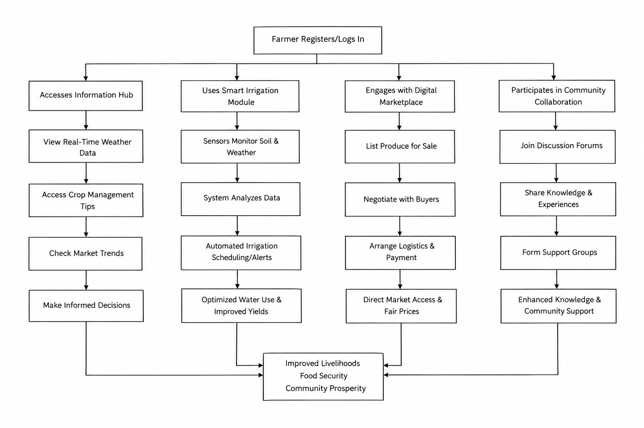

CHAPTER 5: SYSTEM DESIGN
5.1 Introduction to System Design and Nature of the System
This chapter focuses on the design of the Agritech for Rural Prosperity System. The system is designed to make farm record-keeping easier by moving it from manual methods to digital platforms. It will also integrate market information, provide real-time farming advice, and improve communication between farmers and agricultural extension officers. The system uses an object-oriented approach, where real-life entities such as farmers, extension officers, farm records, advisory services, and market platforms are represented as different components of the system.
The system will use a modular architecture, where different modules such as farmer registration, record-keeping, market integration, smart irrigation, advisory services, and reporting work together to provide the required functions. This chapter describes the different tools, models, and diagrams that will be used in designing both the logical and physical aspects of the system.
5.2 Design Objectives
While designing the system, the following key objectives will be considered:
- Accessibility: The system will provide an easy-to-use platform that can be accessed by farmers, agricultural extension officers, and market agents.
- Efficiency: The system will automate activities such as keeping farm records, monitoring irrigation, and providing market updates to help improve productivity.
- Data Integrity: The system will ensure that farmer information, farm inputs, outputs, and other rural communities and adapted to support different agricultural value chains. transactions are recorded accurately and properly maintained.
- Privacy: The system will protect farmers’ personal and other sensitive information through the use of authentication and data encryption.
- Scalability: The system will be designed in a way that allows it to be expanded to other rural communities and adapted to support different agricultural value chains.
5.3 Program Design Tools
These are the tools to be used in designing the application. They are the same tools discussed in Chapter Three, methodology.
5.3.1 Flow Chart
This is the flow chart of the proposed system which outlines the typical interaction flow from farmer registration to accessing advisory services, record management, and market integration.
5.3.2 Use Case Diagram
This diagram illustrates the interactions between the users (farmers, extension officers, administrators, and market agents) and the system.
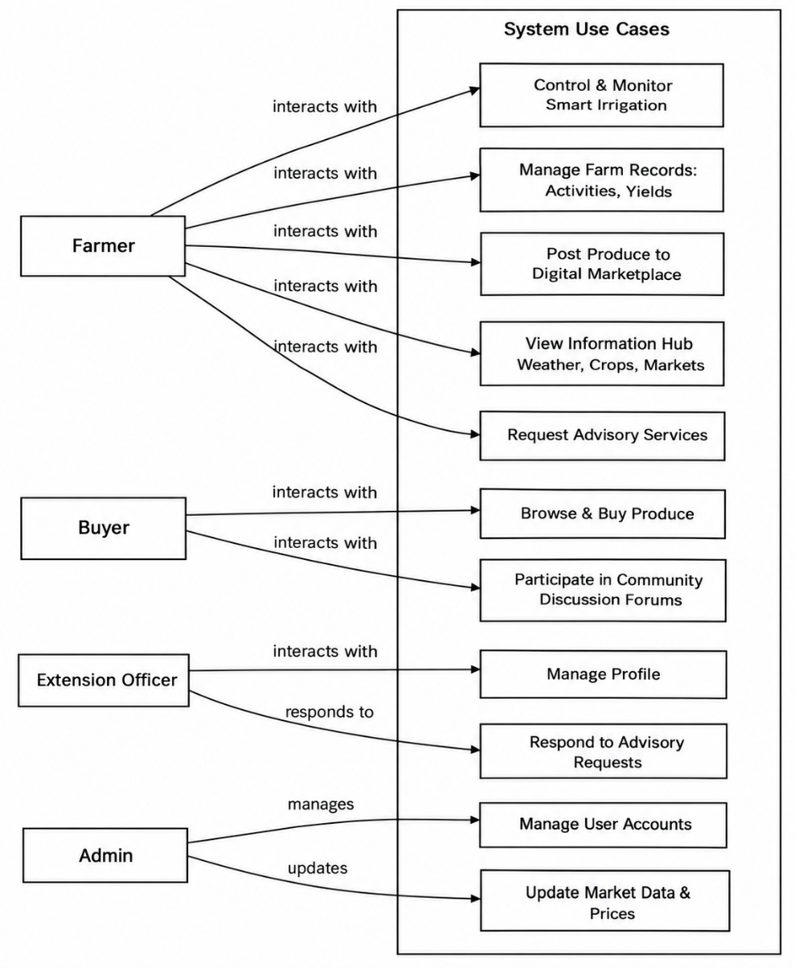

5.3.3 Data Flow Diagram (DFD)
The DFD illustrates how data moves through the system, including data input, processing, storage, and output. It covers activities such as farmer registration, recording farm activities, requesting advisory services, and accessing market information.
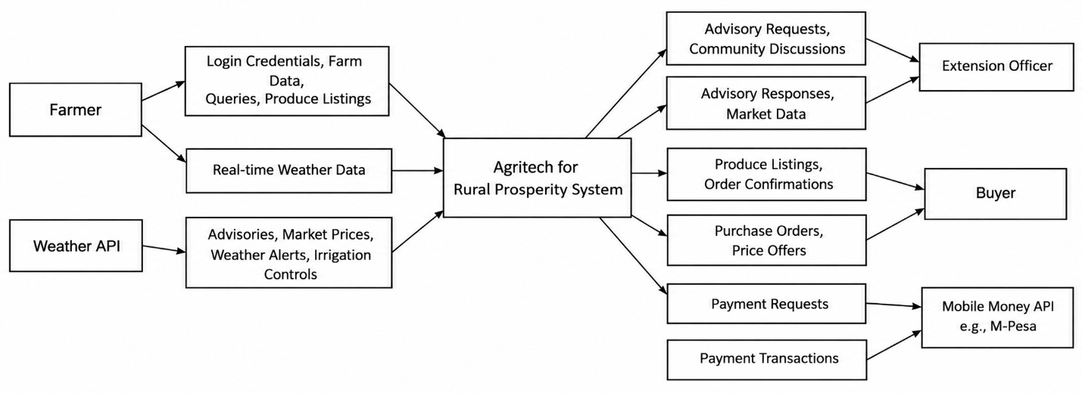
5.4 Logical Design
5.4.1 Logical Data Design
This involves identifying and organizing the different entities and their relationships before designing the physical database. Tables are created from normalized data to reduce duplication and maintain proper relationships between the data. The main entities identified include:
- Farm Records
- Advisory Services
- Market Data
- Extension Officer
- Feedback
5.4.2 Entity Attributes Relationships
Each entity will have attributes and relationships represented in an ERD diagram.

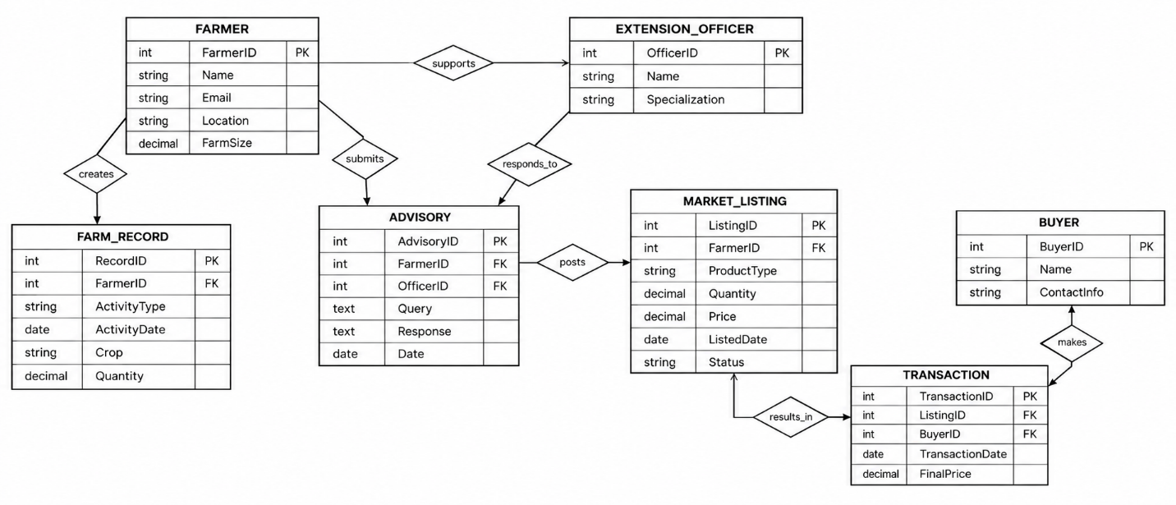
5.4.3 Entity Life History (ELH)
The ELH diagram tracks the lifecycle of each record, especially for recurring processes like farm activity records, irrigation monitoring, market updates, and advisory service requests.
5.5 Physical Design Description
5.5.1 Data Dictionary
Table 1: Farmer Table
Data Name | Data Type | Description | Allow Null
FarmerID | Integer | Unique Identifier | NO
Name | String | Full name of farmer | NO
Age | Integer | Age of farmer | NO
Location | String | Geographical region | NO
FarmSize | Decimal | Size of farm in acres | NO

Table 2: FarmRecord Table
Data Name | Data Type | Description | Allow Null
RecordID | Integer | Unique Identifier | NO
FarmerID | Integer | Foreign key linking farmer | NO
Activity | String | Type of farm activity (planting, weeding, harvesting) | NO
Date | Date | Activity date | NO
Output | Decimal | Quantity harvested or recorded | YES

5.5.2 Database Design
The system will use MongoDB to store farm records, advisory logs, and feedback in a flexible way. Different collections will be used to represent entities such as farmers, farm records, market data, and advisory services. The relationships between these entities will be maintained using unique identifiers.
5.5.3 Input Screen Design
The input screens are designed to capture:
- Farmer registration details
- Farm activity updates
- Market price entries and updates
- Advisory requests
- Feedback submission
5.5.4 Output Screen Design
The output screens include:
- Confirmation messages after record entry or advisory requests
- Farm record summaries viewable by farmers and extension officers
- Market dashboard with real-time prices and trends
- Reports summarizing yields, advisories, and market access

5.5.5 Code Design
The system has been developed using the MERN stack, which consists of MongoDB for managing the database, Express.js and Node.js for handling the backend, and React.js for developing the user interface. This architecture uses a modular and object-oriented approach, making the system easier to maintain and allowing it to be expanded in the future.
The backend is structured around models and controllers with key classes such as:
- FarmerController – handles farmer registration, authentication, and profile management.
- FarmRecordController – manages farm activity entries and output updates.
- AdvisoryController – processes farmer queries and provides expert or AI-driven advice.
- MarketController – integrates and updates market data for farmers.
- FeedbackController – collects farmer feedback for system improvement.
The frontend React components follow a reusable structure using props and state management with hooks. Major components include:
- RegistrationForm
- LoginPage
- FarmRecordForm
- AdvisoryRequestForm
- MarketDashboard

MongoDB serves as the NoSQL database, where collections such as farmers, farm records, market data, and advisory store user data, activities, and advisory logs. The system is designed for RESTful interaction, enabling seamless API communication between frontend and backend through JSON-based HTTP requests. JWT is used for secure user authentication.

CHAPTER SIX: SYSTEM IMPLEMENTATION
Introduction
This chapter describes the implementation of the Agritech for Rural Prosperity System. It explains how the different modules of the MERN stack-based platform were developed and integrated to provide the required functions. The chapter also covers the tools used during coding, debugging methods, system testing procedures and results, test data and validation, as well as the proposed change-over strategy. The main aim is to show that the developed system meets both the functional and non-functional requirements.
6.1 Coding/Environment/Debugging Techniques
6.1.1 Coding Tools
The system was developed using the MERN stack, which comprises:
- MongoDB: NoSQL database for storing farmers, farm records, advisory logs, and market data.
- Express.js: A web application framework for Node.js to build the RESTful API.
- React.js: Frontend JavaScript library used to create the user interface.
- Node.js: JavaScript runtime for executing backend logic.
- Mongoose: ODM (Object Data Modeling) tool used to connect and work with MongoDB from Node.js.
- Postman: Used for API testing during development.
- Visual Studio Code (VS Code): Main IDE used for both frontend and backend development.
6.1.2 Development Environment
- OS: Windows 10 (development & deployment environment)
- IDE: Visual Studio Code
- Version Control: Git & GitHub
- Browser for Testing: Google Chrome
- Runtime: Node.js v18+
- MongoDB Atlas: Cloud-hosted database
6.1.3 Debugging Tools
- Browser Developer Tools: Used to inspect elements, monitor console logs, and debug frontend issues.
- .Postman: Used to manually test API routes during development and confirm backend behavior.
- Mongoose Error Handling: Built-in error messages and validation for database operations.
- VS Code Debugger: Breakpoints and step execution for both server-side and client-side code.
- Console Logging: console.log() was heavily used in both frontend and backend to trace the flow of data and detect anomalies.
6.2 Program Listing
Program code is modularized into components and controllers. A complete listing of key parts of the system is provided in the Appendix, including:
- server.js – Entry point of the backend
- FarmerController.js – Handles farmer registration, login, and profile management
- FarmRecordController.js – Manages farm activity records and output updates
- AdvisoryController.js – Handles advisory requests and responses
- MarketController.js – Integrates and updates market data for farmers
- AdminDashboard.jsx – Frontend admin panel logic
- FarmerProfile.jsx – Frontend farmer profile and activity flow
6.3 System/Program Testing
System testing was conducted to ensure all components functioned as expected and integrated correctly. We applied unit testing on backend routes and manual exploratory testing on frontend functionality.
Testing Objectives
- Ensure proper flow from farmer registration to accessing market data and advisory services.
- Validate farm record entries and updates.
- Ensure role-based access for farmers, extension officers, and administrators.
- Test field validations to prevent incorrect or incomplete submissions.
Confirm system security in authentication and authorization flows.
Test Case Summary
Table 6: Case Summary
Test Case | Description | Expected Result | Status
Farmer Registration | Register new farmer with valid data | Account is created and stored in MongoDB | Pass
Farmer Login | Login with correct email and password | JWT Token issued and access granted | Pass
Add Farm Record | Farmer submits farm activity (planting, weeding, harvest) | Record saved in DB and displayed in profile | Pass
Request Advisory | Farmer submits a query to extension officer | Advisory logged and displayed in user dashboard | Pass
Access Market Data | Farmer views updated crop prices | Data retrieved from DB and shown on dashboard | Pass
Admin Updates Market Data | Admin posts new market prices | Database updated and farmers notified | Pass
Invalid Form Submission | Submit with empty/invalid fields | Error messages shown, submission blocked | Pass
Unauthorized Access | Farmer tries to access admin route | Access denied (403 response) | Pass

6.4 Test Plan
Each module of the system was tested independently using unit and functional testing techniques:
- Frontend Forms: Tested with both valid and invalid inputs.
- Backend APIs: Verified using Postman with correct and incorrect payloads.
- Database: Verified data creation, update, retrieval, and deletion using Mongoose queries.
Validation included:
Email format
Required fields (name, location, farm size)
Status transitions for records (Created → Updated → Archived)
6.5 Test Data
The following database schemas were used to test application functionalities:

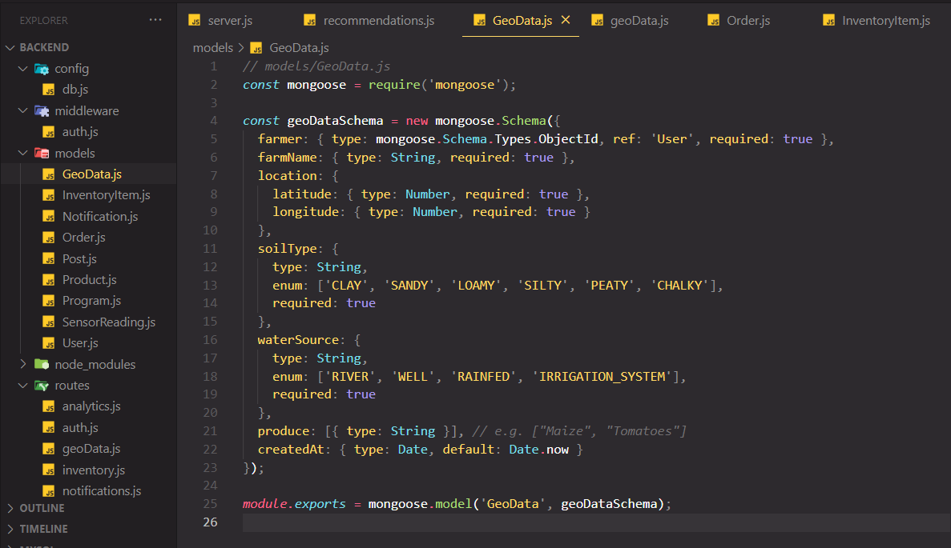

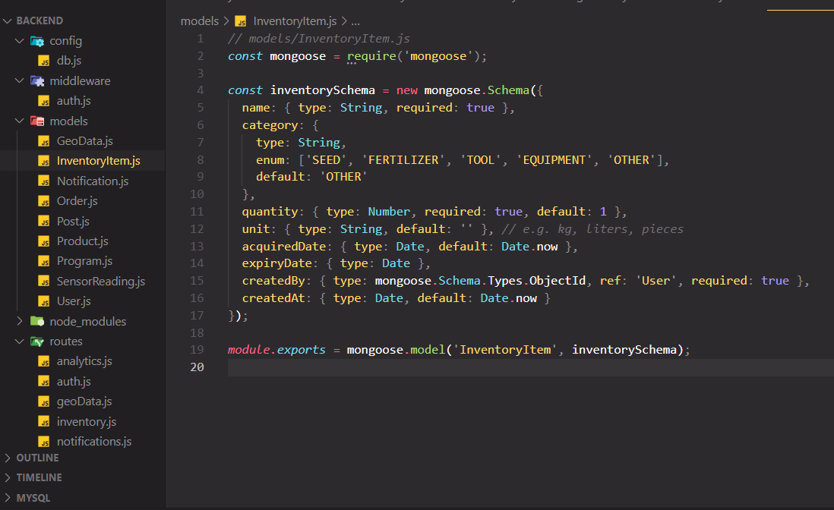
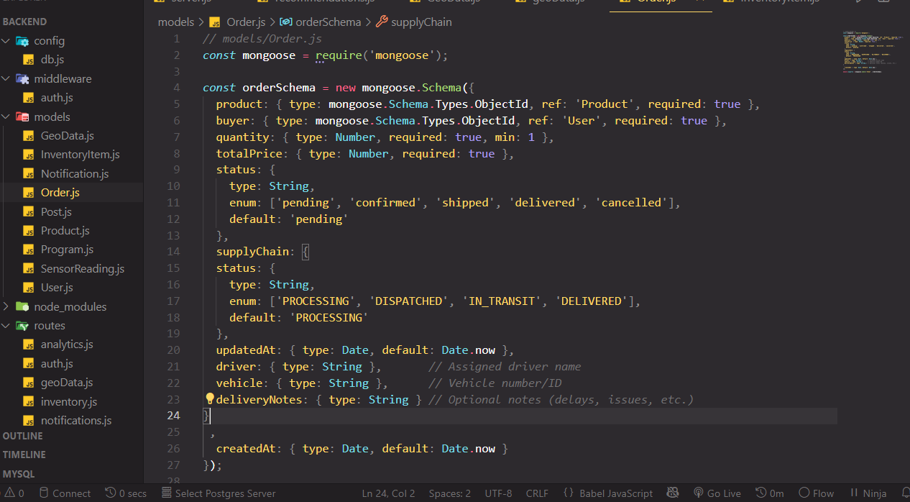

6.6 Sample Run – Output Results
Farmer Dashboard View
i. Displays farmer profile info
ii. Shows submitted farm activity records
iii. Displays advisory messages from extension officers
iv. Provides real-time market price updates
Admin Panel
i. Lists all registered farmers and their activities
ii. Options to respond to advisory requests
iii. Ability to update market data
- Generate reports on farmer activities and yields

CHAPTER SEVEN: USER MANUAL - DOCUMENTATION
7.1 Installation Environment
The system is a web-based application developed using the MERN stack (MongoDB, Express.js, React, Node.js). It is designed to run in modern web browsers across multiple devices (desktops, tablets, smartphones).
- Farmers can access their accounts via a browser on their phones or computers.
- Extension officers and administrators can access the admin panel via a secured login route.
- Since it is hosted online, the system does not require installation on client devices.
7.2 Installation Requirements
Because the system is browser-based, installation requirements are minimal.
User Requirements:
- A device with a modern browser (e.g., Chrome, Firefox, Safari)
- Internet connection
Admin Requirements:
- Device with larger screen size (10 inches or more recommended) for easier data management
- Keyboard input enabled device
For Local Hosting (development setup):
i. Node.js (v18 or higher)
ii. MongoDB Community Server
iii. Internet or LAN connectivity
iv. Git (optional for version control)
7.3 Installation Procedures
For Farmers and Users (Web Access):
i. Open a modern browser.
ii. Navigate to the official Agritech for Rural Prosperity system URL.
iii. Create a user account or log in to an existing account.
iv. Start using the platform to record farm activities, request advisory services, or access market data.
For Admins (Local Setup - Development Purposes):
a. Clone the repository:
git clone https://github.com/
b. Navigate into the frontend and backend folders and run:
npm install
c. Set up .env files with MongoDB URI and server configurations.
d. Start the server and frontend:
npm run dev
e. Access the application via http://localhost:3000
7.4 User Instructions
7.4.1 User Registration
Farmers must register to access system services.
Steps:
i. Visit the home page.
ii. Click on “Sign Up.”
iii. Fill in details such as full name, location, farm size, email, and password.
iv. Click “Register.”
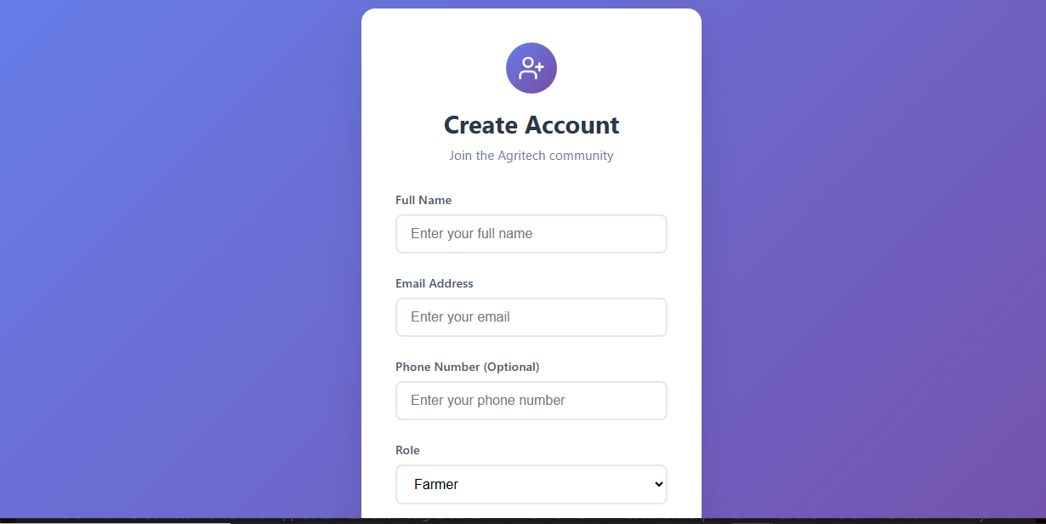7.4.2 User Login
Registered farmers can log into the system to manage records or view advisory services.
Steps:
i. Navigate to the login page.
ii. Enter email and password.
iii. Click “Login.”

7.4.3 Dashboard / Home Page
Once logged in, farmers see their dashboard, which includes:
i. Profile summary
ii. Farm records (submitted activities)
iii. Access to advisory services
iv. Market price updates for major crops
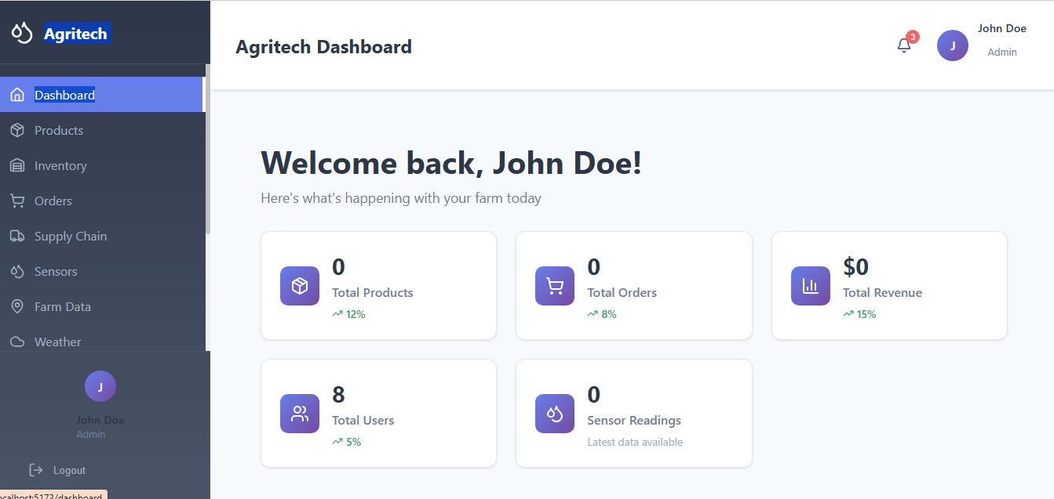7.4.4 Farm Record Entry
Farmers can add or update farm activities.
Steps:
i. Click on “Add Farm Record.”
ii. Enter details (activity type, crop, date, expected output).
iii. Submit the record.
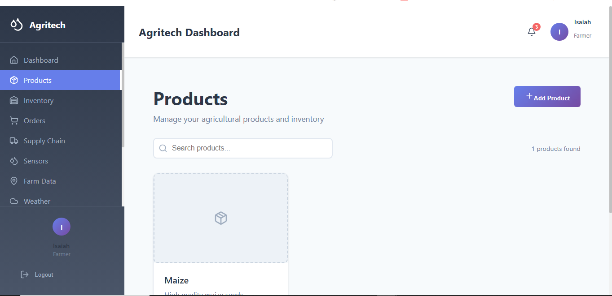7.4.5 Request Advisory Services
Farmers can seek advice from extension officers.
Steps:
i. Go to the Advisory Section.
ii. Enter your query (e.g., pest outbreak, irrigation issues).
iii. Submit the request.
iv. Wait for officer response in your dashboard.
screenshot
7.4.6 Market Data Access
Farmers can view real-time market prices for crops.
Steps:
i. Navigate to Market Data tab.
ii. Select the crop of interest.
iii. View updated prices and trends.
7.4.7 Admin Panel Instructions (For Admins Only)
Admins can:
i. Manage farmer registrations
ii. View and respond to advisory requests
iii. Update market prices
iv. Generate reports on farm records
7.5 System Conversion Method
Since this is a newly developed system, the direct conversion method is used. Once the system is deployed, it will immediately go live for all farmers and extension officers. Pilot testing has already been conducted to ensure reliability, so parallel or phased conversion is unnecessary.
7.6 User Training
The system has a simple, mobile-friendly interface. Training recommendations include:
i. Self-guided training using this manual and short video tutorials.
ii. Workshops/demos for farmer groups and extension officers.
iii. Help desk or chatbot support (optional for future versions).
iv. Minimal digital skills required – users only need basic smartphone or browser knowledge.
7.7 File Conversions
No file conversions are required. All farmer data is collected through system forms and stored in MongoDB. However, administrators can export reports (e.g., CSV/PDF formats) for data analysis and record-keeping.

CHAPTER EIGHT: LIMITATIONS, CHALLENGES, CONCLUSION AND RECOMMENDATIONS
8.1 Limitations
- Although the Agritech system has helped in digitizing agricultural services and improving interaction between farmers and extension officers, a number of limitations were experienced during its development.
- Platform Limitation: The system currently operates as a web application and does not have a native mobile application. This may limit access for some smallholder farmers who have limited access to smartphones or web browsers.
- Time Constraint: The available academic timeframe limited the development of some advanced features, such as AI-based crop advisory services, the use of satellite images for farm monitoring, and predictive analytics dashboards.
- Resource Constraints: Limited financial and infrastructure resources made it difficult to integrate features such as mobile money platforms like M-Pesa, automated market linkage systems, and large-scale sensor-based smart irrigation.
- Connectivity Issues: The system depends heavily on internet connectivity, which can sometimes be unreliable or costly in rural areas where many smallholder farmers are located.

8.2 Challenges
Several challenges arose during the development lifecycle of the Agritech system:
- Learning Curve: Building a full MERN stack solution for the agricultural sector required intensive learning, especially when designing APIs for real-time data flow between farmers, extension officers, and market platforms.
- Deployment Issues: Hosting the application on cloud platforms required troubleshooting deployment challenges such as database connections, environment variable configurations, and CORS-related errors.
- Farmer Engagement: Limited access to real farmers and extension officers during testing made it difficult to validate usability across all farmer categories and regions.
- Data Availability: Accessing reliable and up-to-date agricultural datasets (e.g., market prices, soil data, or weather data) was difficult due to fragmentation of data sources and cost constraints.
8.3 Degree of Success
The Agritech system successfully achieved most of its core objectives:
- Farmer Registration and Profiles: Implemented to allow farmers to register, store farm-related data, and interact with extension services.
- Market Data Integration: Farmers can view updated market information to guide selling and purchasing decisions.
- Advisory Services: Basic advisory services on farming practices and inputs were made available to farmers in real-time.
- Extension Interaction: The system provides channels for farmer-extension officer communication, bridging the gap between rural farmers and agricultural experts.
These achievements demonstrate that the system is functional and provides a solid foundation for future development and scaling.
8.4 Learning Experience
The development of the Agritech system provided valuable experience in both technical and professional areas:
- Technical Skills: Enhanced knowledge and proficiency in JavaScript, React, Node.js, MongoDB, and Express in solving real-world agricultural problems.
- Agricultural Domain Knowledge: Gained deeper understanding of challenges farmers face, including market inefficiencies, record-keeping difficulties, and limited access to advisory services.
- Project Management: Improved ability to scope, plan, and execute an ICT4Agriculture (ICT4Ag) solution under limited time and resource constraints.
- Problem-Solving: Strengthened ability to design user-centered solutions, integrate third-party APIs, and develop scalable modules for agriculture digitization.
This project significantly improved confidence in developing practical digital solutions to support agricultural transformation.

8.5 Recommendations
To make the Agritech system more robust, scalable, and impactful, the following are recommended:
- Mobile Application Development: Create an Android/iOS mobile app (possibly using React Native) for better accessibility, especially in rural communities.
- Offline Functionality: Integrate offline-first features to enable farmers to use the system even in low-connectivity areas.
- AI and Analytics: Add machine learning models for predictive analytics, including crop yield forecasting, pest detection, and weather-based planting recommendations.
- Market Linkages: Expand integration with market platforms and cooperatives to ensure farmers receive fair pricing and market opportunities.
- Payment Integration: Incorporate mobile money (e.g., M-Pesa) to enable farmers to pay for inputs or receive payments digitally.
- Multi-Language Support: Localize the system into local languages (e.g., Swahili, Luo, Kikuyu) to increase inclusivity among diverse farmer groups.
- IoT Integration: In the long term, connect the system with IoT devices (e.g., soil moisture sensors, smart irrigation systems) to automate farm management processes.
8.6 Conclusion
The proposed Agritech System successfully addressed some of the main challenges faced by farmers in rural communities such as Gem, Siaya. It provides digital record-keeping, access to market information, real-time farming advisory services, and better interaction between farmers and agricultural extension officers. Although the project faced limitations related to resources, time, and technical requirements, the system showed potential to improve agricultural productivity, decision-making, and access to markets.
The project also demonstrated the importance of using digital technologies in agriculture and showed how an organized information system can help connect farmers with markets and extension officers. With further improvements and expansion, the Agritech System can be developed into a more comprehensive platform that can contribute to food security, empower farmers, and support sustainable development in rural communities.

REFERENCES
- IFAD. (2021). Policy brief investing in rural livelihoods to eradicate poverty and create shared prosperity. World Bank. (2019).
- Agriculture and development: A brief review of the literature
- JJ Dethier, A Effenberger - Economic systems, 2012 – Elsevier
- [BOOK] SMARTfarm Learning Hub: Next generation technologies for agricultural education: Final report 2018
- S Gregory, R Whannell, R Flavel, J Barwick, D Swain… - 2019 - rune.une.edu.au

- Agriculture and Food. Brookings. (2021). How AgriTech Is Transforming Traditional Agriculture in Emerging Markets.
- Agriculture and Food. FAO. (2020). Digital technologies in agriculture and rural areas. McKinsey. (2019). Agriculture’s connected future: How technology can yield new growth.
- Cropin. (2021). SmartFarm- App for Farm Management.
- Newtopia. (2022). What is Agrotech and how does it benefit farming and agriculture?
- Wikipedia. (2021). Agricultural technology. FAO. (2020). Digital technologies in agriculture and rural areas.

APPENDIX
CODE SNIPPET
